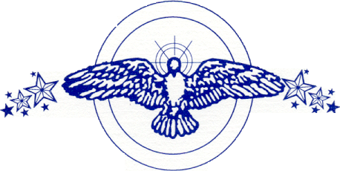

Together has performed throughout the Chicago/Northwest Indiana area. Here are some locations where it has performed:

Hyatt Regency (Chicago/Downtown & O’Hare)
Palmer House (Empire Room & Ballroom)
East Bank Club
Ambassador West
Sheraton Hotel (Chicago/Downtown)
McCormick Place
Conrad Hilton (Chicago/Downtown)
Chicago Yacht Club (Monroe Harbor)
Navy Pier (Grand Ballroom, Crystal Gardens, & Beer Garden)
Magnum’s (Chicago)
Amoco Building (Chicago/Downtown)
Taste of Chicago
Viva Chicago
Pan Am Fest (Chicago)
Festival of the Lakes (Hammond, IN)
Oktoberfest (Michigan City, IN)
Labor Dayz Fest (Michigan City, IN)
White Eagle Golf Club (Naperville, IL)
Fairmont Hotel
Marriot Hotel
Radisson Hotel (Merrillville, IN)
Martinque (Evergreen Park, IL)
Chicago Aquariam
Chicago Field Museum
Chicago Science and Industry Museum
United Center
Indian Lakes Resort
Olympia Fields Country Club
Empress Casino (Joliet, IL)
Trump Casino (Buffington Harbor)
Ameristar (East Chicago, IN)
Blue Chip Casino (Michigan City, IN)
Renaissance Hotel (Chicago/Downtown)
The Four Seasons Hotel (Chicago/Downtown)
The Venue (Horseshoe Casino)
The Knickerbocker Hotel
The Drake Hotel
The Star Theatre (Merriville, IN)
The Sofitel Hotel (Chicago/Downtown)
The Nature Museum
The Peninsula Hotel (Chicago/Downtown)
The Willowbrook Ballroom
…and more.

